Validation Queries Screenshots

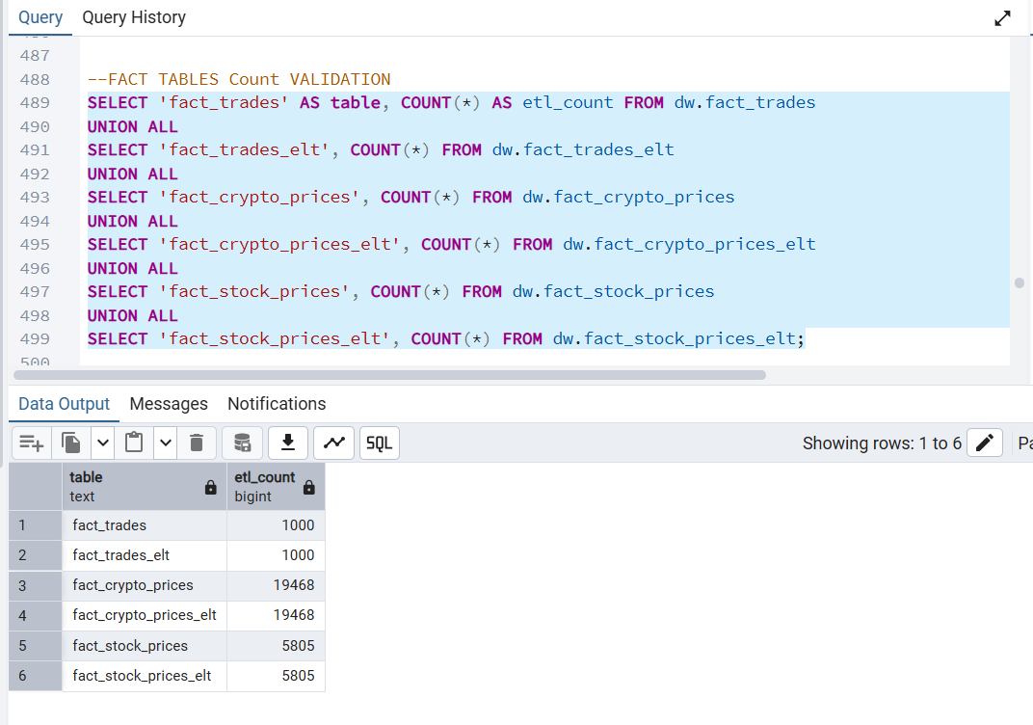

Dimension Tables
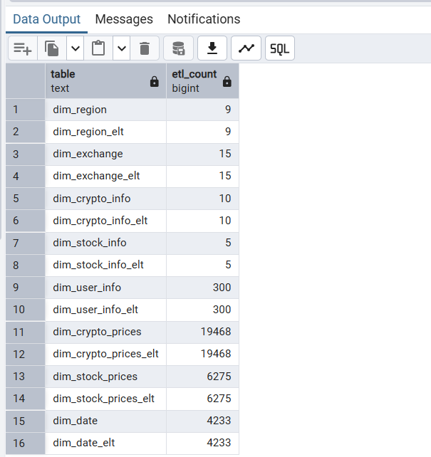

Sum and Count Comparisons b/w Facts

Fact_Crypto_Prices Validation
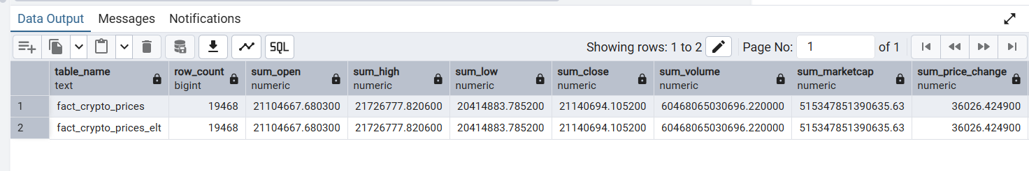

Fact_Stock_Prices Validation
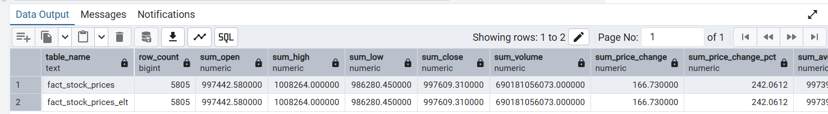

Fact_Trades Validation
